Advocate Care: How well do you take care of your advocates

Advocate Bill of Rights
Recognizing that Advocates in the gender-based violence services and prevention field face the risk and actual effects of vicarious trauma, direct threats/violence, compassion fatigue, moral injury of operating within an oppressive system, and accelerated burnout.
You have the right to:
- safe, considerate and respectful interactions with team members (coworkers, supervisors, leadership, board members, etc.) and others (clients, collaborating public servants, funders, general public, etc.)
- expect that all communications and records pertaining to your involvement (employment, access to services, etc.) with the organization.
- receive complete information about hiring, responsibilities, compensation, organizational structure/values/goals/strategic plan, etc. in terms that are easily understood. (Value: Transparency)
- receive in advance information necessary for you to make decisions regarding safe accommodations and personal care needs with adequate time for implementation prior to termination, decrease in hours or rate of pay. To receive support during the transition to the next phase (e.g. contact with future employer, letters of recommendation, training, mentorship, alumni inclusion, etc.)
- receive routine “reasonable accommodations” to support full work contribution without barriers.
- know in advance of organizational processes (strategic planning, reporting, evaluation, onboarding/exiting, etc.) and requirements for participation.
- receive appropriate support for mental health and overall wellbeing.
- refuse to participate in activities/tasks that do not align with one’s values, mental health and safety.
- use/share examples/templates(?) of your work in the future.
- transparent supervision/mentorship/organizational support that facilitates belonging(?).

Based on the Patient’s Bill of Rights (originally created by the American Hospital Association, 1973, updated in 1992), then adapted by the U.S. Departments of Health and Human Services, Labor and Treasury and adopted by the U.S. federal government in 2010.

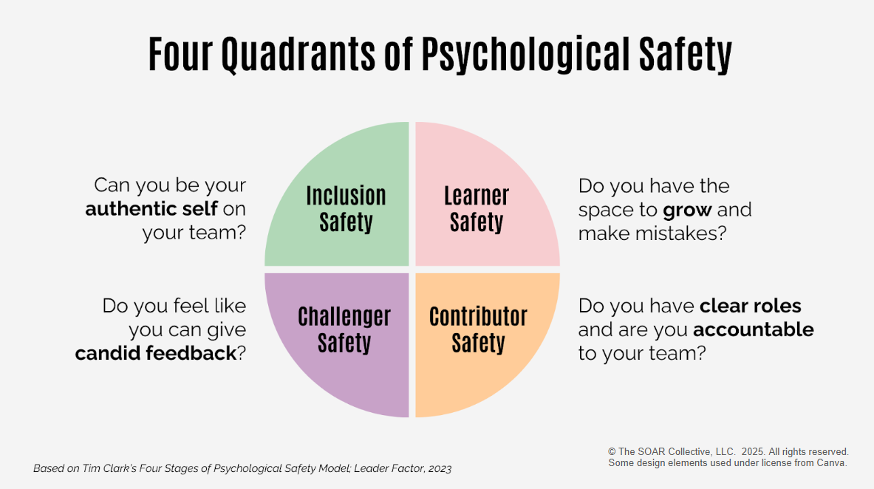

Psychological health and safety
https://www.worksafebc.com/en/health-safety/create-manage/managing-psychological-health-safety
Highlight: (this aspect of psychological health and safety doesn’t require increased costs to improve)
Job Design – employees are not provided clear roles, growth opportunities, or a sense of appropriate autonomy. Job design directly affects workload, demands, and job control. Hazards can include:
- Low role clarity
- Poor job fit
- Low job control
- High or low variety of job tasks
- High or low job demands
- Prolonged, unreasonably excessive workload
Suggested improvements:
- Formal and informal opportunities for worker input on their job.
- Allow workers to be open and honest about challenges of the job
- Listen to ideas for potential job modifications
- Take action and provide resources when possible

Trauma Informed Workplace – SOAR Collective
Trauma Informed Workplaces include:
- Transparent and clear communication with all staff
- Fairness and consistency with policy implementation
- Encourage collaboration, collective problem solving, and community building in the workplace
- Flexible work schedules
- Valuing and taking action when staff voice their concerns
- Recognizing the diversity of trauma and the societal implications of trauma
- Regularly assessing workplace culture

Components of a Workplace Wellness Program
- Physical wellness: regular physical activity, fitness classes, gym access, walking, etc.
- Mental Health Support: resources, counseling, therapy, workshops
- Preventative health: doctor, dentist, vaccinations, holistic, massage, chiropracter, etc.
- Health education: healthy eating habits, nutritious snacks, well balanced meals
- Work-life balance: flexible schedules, clear policies, off-work boundaries
Which of these can you provide paid time for?

Organizational audit of advocate care
Take a look at:
- Benefits: what benefits are you offering your advocates? Here is a list of different benefits to see what you are already offering, and get new ideas for benefits to offer.
  - Paid time off
  - Vacation time
  - Sick days
  - Family days
  - Health care
  - Well-being spending account
  - Retirement plans
  - Sabbaticals
  - Maternity leave
  - Paid self-care/wellness time
- Policies and Standard Operating Procedures: are these up to date? Do your policies and SOPs reflect how your organization is actually being run? Policies are part of building a trauma informed organization so updating and maintaining policies is a big part of relieving advocate stress and uncertainty.
  - Benefit policies – are all the above benefits cleary explained?
  - Work policies for all your different departments and programs
  - Disciplinary action
  - Complaints/disputes (need a better word here)
  - Travel
  - Use of personal car, phone, etc.
  - Crisis line
  - On-call
  - Communication channels
  - Promotions
  - Internal job applications
  - Grant reporting
  - Program reporting
  - Emergencies
  - Debriefing
  - Staff meetings
  - Fundraising
  - Onboarding
  - Hiring/firing procedures
  - DEIB

- Professional development opportunities
- Cross training opportunities
- Allowing for autonomy
- Improving work environments
- Improving pay
- Providing therapy – one-one, group
- Ongoing coaching
- Support current needs plus future desires
- Team building
- Flexible work schedules
- Listening/idea sessions
- Including advocates in more decision making
- Including advocates in strategic planning
- Improve onboarding process
  - Self-determined steps for onboarding (top down/bottom up, cadence, etc)
  - Shadowing
  - Mentoring
  - Supported work
  - The first 90-days – don’t expect new staff to be 100% productive
  - Reviews
  - Assign onboarding contact
  - Who should they meet and talk with?
- Employee Resource Groups
- Transparency/vulnerability (to your comfort level)

Resources
https://www.worksafebc.com/en/health-safety/create-manage/managing-psychological-health-safety
https://www.glassdoor.com/blog/3-reasons-employee-wellness-can-improve-employee-engagement/
https://risepeople.com/blog/workplace-wellness-programs/

